CSE 201 Project High Level Design Document

## Team Member Names

<Please enter your team number and names here>

Group 10

Yi Wang

Xuyang Zou

Weihan Huang

Amelia Rose Mcle

## Team Project Title

Study Toolkit

### Project Description

It’s a website let people proved answer for questions. People can create an account then post a question on the website or search an answer of a question. Also, people can make commons or make modified to their own answer later. They can like or dislike an answer and see similar question on the sit. There is a profile page for each user, included the number of questions and answer that person post. There are two themes, one is coding, the other one is math. The name related to the math theme called math Toolkit which included most of the mathematical functions people can search for.

## Overall Design Description

<Describe the overall design – mention if this is Object Oriented Design or Functional/Procedural design, what components it has (UI, Backend, Front end, Database in backend etc) – use UML diagrams if you want or simple block diagrams>

Our design is to have a database to store all the user’s data such as the profile, the questions that user post before. We will also have a UI to connect the database to let user log in to their account. For this project we may not have frontend but we may have our database in the backend.

## UML Diagram

<Include a short text description of what the UML diagram is showing and then cut and paste your UML diagram here. Use a minimum of 1 class diagram, 2 Use Cases and 2 Sequence diagrams. You are not required to do the OPT and ALT cases in the Sequence diagrams.>

**USER CASE UML**

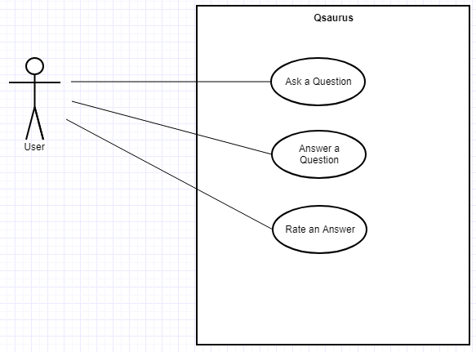

Save to Database

***CLASS DIAGRAM***

|  |
| --- |
| Question |
| +author:User(1)  #questionID: int(1)  +questionText: String(1)  +questionImage: Image(many)  +questionTitle:String(1)  +taggedWith:Tages  -adminComments:Comments |
| +constructor:question(author: user, String questions)  -deleteQuestion(): Boolean  -deleteComments():boolean |

***Sequence UML***

